When divine justice feels delayed

Kevin Liston Flashes of Insight November 25, 2025 www.flashesinsight.com



·
In a recent Sunday Gospel (Luke 18), Jesus claims, “I promise you; God will see justice done to them [God’s chosen ones], and done speedily.”
I found this a challenging, even confronting, reading.

The problem
Jesus’ claim that God will see that his chosen ones will get justice quickly is not supported by the facts. The evidence is just not there.
Ask anyone in Gaza or Ukraine or the hundreds of homeless families in Australia or anywhere in the World.
God does not intervene directly in human affairs as if to correct some miscalculation in the original creation plan. God does not have afterthoughts.
So, how could Jesus be so positive about God coming to help people “who cry to him”? And why did Luke put it in his book?

Faith
I think the faith Jesus referred to had nothing to do with divine intervention through simple miracles but everything to do with our human capacity for love, care, empathy, and a willingness to live authentically.
I think of faith as an orientation to mystery, to an unknown that I call God. God is my word for the something or someone that underpins the existence of the universe and all that is in it. While this “Being” is totally transcendent, it also permeates everything.
As an orientation to fulfilment, faith makes sense of life, creating direction and purpose. It gives me hope and offers me an open-ended love. Faith in God is also faith in humanity and the whole universe, or it is not faith at all.
Pope Francis, in both Laudato Si’ and Fratelli Tutti, was emphatic that we humans are kin to all that is. We live in a friendly universe.
Through our creation — our coming into being as incarnations of divinity, with the Spirit of God in our hearts — we have in ourselves the seeds of faith and love, and the power to change the world.
If God is to fix up the world and bring about peace and harmony, it will be humans who make it happen. Collectively, we have within us the capacity, ability, and responsibility to hear the “cry of the poor” and act accordingly.

Prayer
I think of prayer as faith seeking expression.
When I pray for my sick brother in Ireland or my granddaughter’s exam success or the people of Gaza, I am ultimately praying to the divinity in people, putting my trust in others to be intelligent, responsible, and loving.
That requires a lot of faith.
When Jesus said that God will come quickly to the help of the poor and oppressed, he was expressing his faith in humanity.
I think he was saying that people of faith would be first responders for the “chosen ones who cry out for help day and night.” He is metaphorically saying, “Surely people with faith will not delay in coming to help!”
He finishes with a challenge: “When the Son of Man comes, will he find any faith on earth?” In other words, “In the future, will people have faith?”
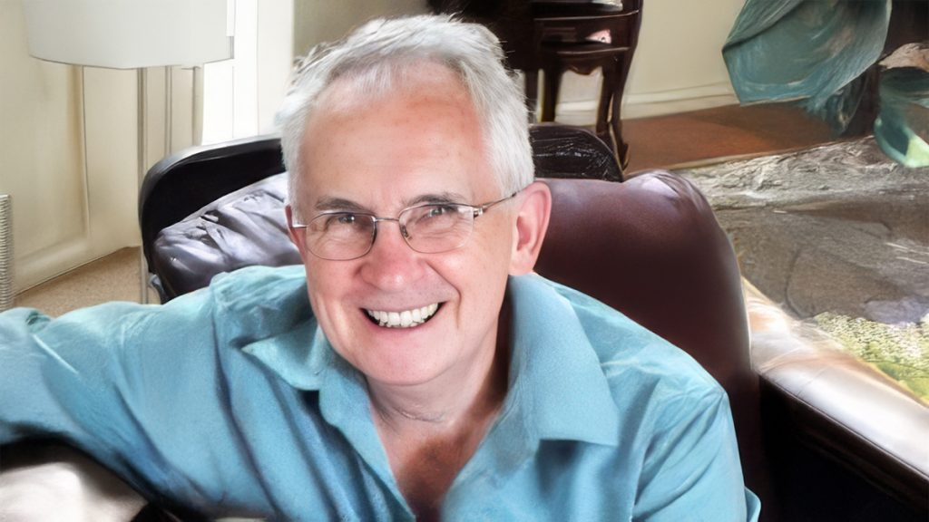
- Kevin Liston is a Co-chair of the ACCCR (Australasian Catholic Coalition for Church Reform), Convener of SACEC (SA Catholics for an Evolving Church), a member of the State Council of the St Vincent de Paul Society (South Australia), and active in a local Vinnies conference. After retiring, he completed a Master of Theological Studies at ACU and a Graduate Diploma in Psychology at Monash University. This article is written in a personal capacity.

